**Database System LAB Practical 7**

**Creating Tables:**

**Sailors:**

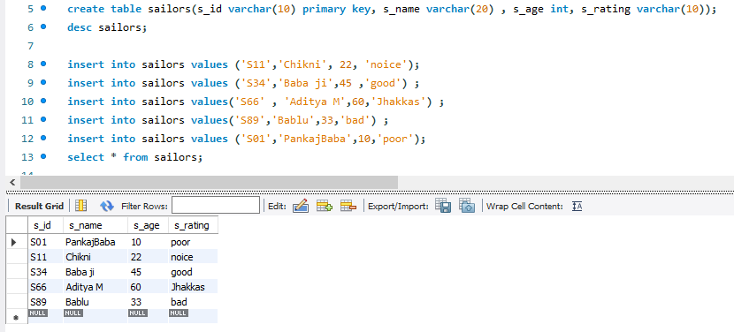

**Boats:**

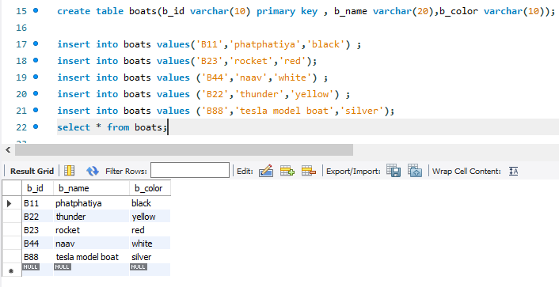

**Reserves:**

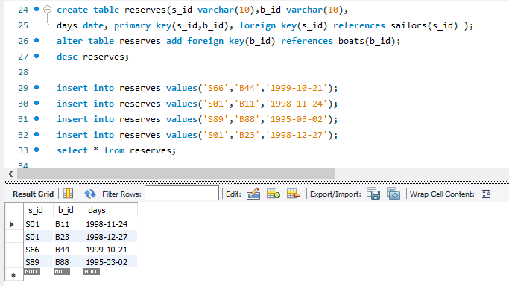

**Questions:**

**Q1: Find the s_id of the sailors who have reserved red boat but not green boat.**

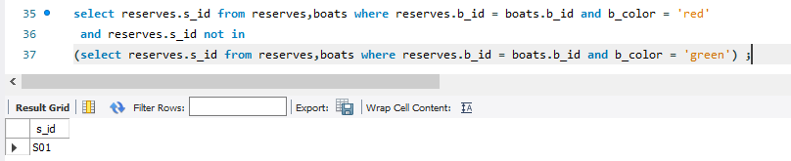

**Q2: Find the s_id of the sailors who have reserved red boat or green boat.**

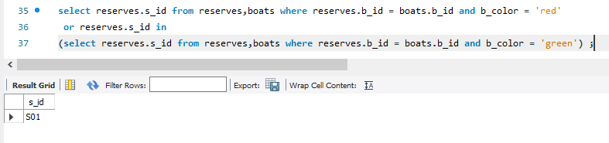

**Q3: Find the s_id of the sailors who have reserved both red boat and green boat.**

